**Analysing Adaptive Responses of Smallholder Black Pepper Farmers in Kerala: A Choice Modelling Approach to Climate Change-Relevant Decisions.**

1Assistant Professor, Department of Agricultural Extension Education, College of Agriculture, Vellayani, Thiruvananthapuram, Kerala Agricultural University, Kerala, India.

[smija.pk@kau.in](mailto:smija.pk@kau.in)

2Assistant Professor and Head, Department of Agricultural Statistics, College of Agriculture, Vellayani, Thiruvananthapuram, Kerala Agricultural University, Kerala, India

[pratheesh.pg@kau.in](mailto:pratheesh.pg@kau.in)

orcid id- 0000-0003-3290-0436

3Assistant Professor, Division of Social Sciences, Regional Agricultural Research Station, Pattambi,Kerala Agricultural University, Kerala, India.

[neetha.cd@kau.in](mailto:neetha.cd@kau.in)

orcid id- 0000-0003-1553-9300

4 Professor, Department of Plant Physiology, College of Agriculture, Vellayani, Thiruvananthapuram, Kerala Agricultural University, Kerala, India

[roy.stephen@kau.in](mailto:roy.stephen@kau.in)

**Abstract**

This study investigates the complex dynamics of climate resilience strategies among smallholder pepper farmers in Kerala, India. Employing a mixed-methods approach, including Best-Worst Scaling (BWS) analysis, conditional logistic regression, and attribute level preferences, we explore the decision-making processes underlying the adoption of various adaptation practices. Our findings reveal that a combination of practices, characterized by exclusive organic farming practices, diversified cropping systems with cardamom integration, and the preservation of selected landraces, is the most favoured resilience strategy among respondents. Despite concerns over increased maintenance costs, farmers perceive organic farming as conducive to long-term sustainability and autonomy. Conversely, mixed choice responses towards the perceived utility of grafted pepper plants for flood and disease tolerance throw light on the importance of institutional validation for decision-making regarding technological adoption. Furthermore, respondents prioritize landrace diversity and diversified cropping systems, reflecting an inclination towards genetic preservation and sustainable farming practices. The study also highlights a strategic shift towards three-tier diversified systems, incorporating cardamom, to mitigate market volatility. However, concerns arise over the potential reduction in black pepper acreage. These findings provide valuable insights for policymakers and agricultural stakeholders and guide future pathways of adaptation decisions aiming to promote climate-resilient practices and enhance the sustainability of smallholder farming systems.

**Keywords**: Black Pepper, CCRDs, Climate-change, resilience, Decision making,Best Worst Scaling (BWS), Sustainability, Smallholder farmers

1. **Introduction**

Black Pepper, revered as "Black Gold" and the most widely used spice in the world, stands as an iconic commodity in global trade. It is cultivated in over 26 countries, collectively producing approximately 315–320,000 tons of pepper annually, including both black and white varieties (Ravindran & Kallupurackal, 2012). Its origins are deeply rooted in the lush landscapes of Kerala, a South Indian state renowned for its rich tradition of spice cultivation. Contributing significantly to India's agricultural landscape, black pepper holds a prominent position, with major cultivation hubs in Karnataka, Kerala, and Tamil Nadu. Despite its historical significance and economic importance, the black pepper industry faces multifaceted challenges stemming from climatic variability, environmental stressors, pests and diseasesand economic volatility.(Anith *et al*., 2018; Kandiannan*et al*., 2014)

The production dynamics of black pepper in Kerala reflect the intricate interplay between natural phenomena and agricultural practices. Notably, the state experienced a tumultuous period marked by devastating floods in 2018 and 2019, leaving enduring impacts on soil quality and fertility (Figure 1). Studies conducted post-flood underscored a discernible decrease in essential soil nutrients, complicating the agricultural landscape (GOK, 2018; Varghese and Ray, 2024). Furthermore, climatic anomalies, such as erratic rainfall patterns and rising temperatures, have emerged as pivotal factors influencing black pepper cultivation. The delayed onset of the southeast monsoon disrupts critical phases of the plant's growth cycle, including flower initiation, ultimately hampering yield outcomes. Moreover, the reduction in post-blossom rain adversely affects pollination and berry development, exacerbating production challenges. Beyond local environmental factors, the global black pepper market grapples with pronounced price volatility, aggravated by economic variables like currency fluctuations, labour expenses, and weather-induced crop yield variations (Hema *et al*., 2007; Phiri *et al.*, 2024). Smallholder farmers, constituting a significant proportion of producers, bear the brunt of these fluctuations, particularly in less developed countries across Africa and Asia, where climate change impacts are disproportionately severe.

Against this backdrop, this paper aims to explore the intricate nexus between climatic variability, environmental stressors, and agricultural practices, with a specific focus on black pepper production in Kerala, India, a state renowned for its black pepper production. By elucidating the multifaceted challenges confronting the industry, this study attempts to provide insights that inform resilient agricultural strategies and mitigate the adverse effects of climate change on black pepper cultivation.

In response to the escalating challenges posed by climate change, the imperative for farmers to adapt their practices has never been more pressing. Acknowledging the pivotal role of adaptation in ensuring sustainable agricultural yields, the term "Climate Change-Relevant Decisions" (CCRDs) was coined, which encompass actions contributing to both mitigation and adaptation efforts (Schneider *et al.*, 2021). These decisions are framed within cognitive theories, emphasizing the cognitive processes that underpin farmers' adaptation strategies.

The adaptive responses of individuals to climate change are multifaceted and influenced by a plethora of interdisciplinary theories spanning anthropology, geography, cognitive science, political science, psychology, rural sociology, economics, and data science. Through empirical research, these theories have been extended and refined, providing valuable insights into human decision-making in the context of climate change.

By aligning adaptation practices with farmers' cognitive frameworks, interventions can enhance their ability to cope with challenges and bolster their resilience. These efforts typically encompass a blend of psychological support, skill-building initiatives, and the creation of supportive environments conducive to adaptation.Understanding farmers' decision-making patterns and preferences is also essential for crafting effective strategies tailored to market characteristics.(Ola & Menapace, 2020; Burnham & Ma, 2016)

In this study, we delve into the adaptation strategies employed by smallholder black pepper farmers in the major cultivation regions of Kerala, India. Specifically, we address two interconnected sub-questions: (1) what adaptation strategies do smallholder farmers in these regions typically employ in response to climate change? (2) Which adaptation practices do farmers prioritize to ensure sustained income from their plantations? (Smith *et al*., 1999). We utilize Best-Worst Scaling (BWS) as a method to analyse the adaptive responses of smallholder black pepper farmers in Kerala to the challenges posed by climate change. BWS is a powerful technique that allows us to explore farmers' preferences by asking them to identify both the best and worst options within a set of adaptation strategies. This approach offers several advantages, including capturing the relative importance farmers assign to different strategies, reducing response bias by forcing respondents to make trade-offs, and creating a decision context that mirrors real-world scenarios (Ahoudu*et al.*, 2023; Shittu *et al.,* 2021)

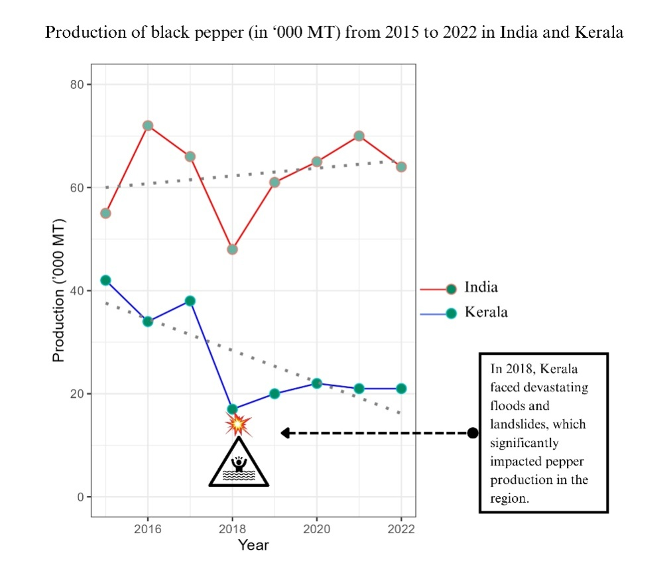

Figure 1 Production of black pepper from 2015 to 2022 in India and Kerala

**2. Materials and Methods**

2.1 Study area

The selection of study areas was based on the consideration of multiple factors, primarily focusing on the significance of two districts in Kerala's black pepper production. Among the 14 administrative districts in Kerala, Idukki and Wayanad were identified as focal points due to their exceptional prominence in black pepper cultivation. In the 2019-20 period, Idukki (Southern hills) stood out with a sprawling area of 42,822 hectares dedicated to black pepper cultivation, yielding a production of 20,560 tons, and achieving a productivity rate of 480 kg/ha, where national and state productivity was 235.39 and 239 kg/ha respectively. Similarly, Wayanad (Northern Hills) exhibited substantial figures, with 10,307 hectares under black pepper cultivation, resulting in a production of 3,694 tons and a productivity rate of 358 kg/ha. These districts not only lead the state in terms of area, production, and productivity but also contribute significantly to the state's overall black pepper output, with Idukki alone accounting for as much as 59.52% of the total production.The distinctive agricultural practices, environmental conditions, and socio-economic factors prevalent in these areas offer a variety of levels of adaptation practices conducive to a choice experiment with BWS profile analysis, that would generate valuable insights into the dynamics of black pepper cultivation in the light of climate resilience, thereby justifying their selection as primary areas of focus in the study.

The Kerala state is divided into 23 agro-ecological units (AEUs) depending upon various factors such as topography, soil types, climate patterns, and vegetation cover. These AEUs acknowledges the heterogeneity of Kerala's terrain and the importance of considering local environmental conditions in agricultural decision-making. The five AEUs having higher area of cultivation under black pepper were purposively selected from the Idukki (3 AEUs) and Wayanad (2 AEUs) districts. Areas from these AEUs were selected purposively depending upon the prevalence of climate change related events as reported by the government agricultural office (*Krishibhavan*), during the preliminary survey. The small holder farmers who possess land holding up to 5 acres were randomly selected from the list obtained from the *Krishibhavans*. Significant contributions of these areas to the overall state production, as well as their diverse geographical and socio-economic characteristics, make them ideal subjects for comprehensive analysis. Moreover, the unique agricultural practices, environmental conditions, and socio-economic factors prevalent in these districts offer valuable insights into the dynamics of black pepper cultivation in the light of climate resilience, thereby justifying their selection as primary areas of focus in the study.

The survey was conducted during the period 2022-23 and 2023-24. The best-worst scaling of climate change adaptation alternatives from 198 smallholder farmers of which 150 farmers provided valid responses. Therefore, the effective sample size became 150.

2.2 Theoretical framework

The documentation and analysis of adaptation strategies observed during pilot survey revealed that the motivations behind farmers’ climate change-related decisions (CCRDs) lie beyond traditional concepts of rational decision-making aimed at utility maximisation as empahasised by Habtemariam *et al*. (2019).So,thetheoretical framework guiding this study is built upon Herbert Simon's concept of bounded rationality (1955). We observe that farmers, faced with the multifaceted challenges of climate change, often grapple with incomplete information and cognitive limitations, leading them to experiment with multiple adaptation practices. In such circumstances, farmers tend to make satisficing choices rather than striving for an optimal rational decision.The decision making is constrained by emotional influences, social dynamics, incomplete information processing, heuristics, and cognitive biases, as elucidated by seminal works such as those of Tversky and Kahneman (1974).

The farmers in the study area, having directly experienced climate risks to varying degrees, are expected to be significantly influenced by these differences in risk exposure when making decisions.The Protection Motivation Theory (Rogers, 1983) and the work of Grothmann and Patt (2005) suggest that perceiving risk is a key aspect of how individuals make decisions to adapt. According to this perspective, individuals begin considering taking action in response to climate change threats to their livelihoods once they perceive the risks involved. (Habtemariam *et al*., 2019; Delfiyan *et al*., 2020)

We also observed that a few adaptation decisions including grafting with resistant rootstocks and leveraging traditional knowledge of landraces for commercial nursery businesses resonate with the theoriesput forward by Nelson and Winter in 1982 regarding organizational routines and tacit knowledge.(Becker, 2004). The adaptation pathways emerging out of such organisational routines are poised to give future policy recommendations (Newsham *et al*., 2023).

The study also acknowledges the temporal constraints in CCRDs, which necessitate quick adaptive responses. In response to these constraints, decision-makers often rely on simple, fast, and frugal decision-making heuristics, as proposed by Gigerenzer and Todd (1999). The acknowledgment of decision-making inconsistency, asserted by March (1978) and emphasized by Fiori (2011), motivates the utilization ofchoice modelling and Best-Worst Scaling in gathering responses. (Ola & Menapace, 2020)

Our study employs Best Worst scaling (BWS) theory (Louviere *et al*., 2015) that aligns with the structured information search process inherent in the decision-making environment. By employing this approach, we aimto uncover the decision-making patterns followed by black pepper farmers in addressing climate change-related challenges within their field conditions.

The specific factors that guide individuals in giving varied responses are captured by defining attributes and attribute levels for each adaptation practice. The study refrains from quantifying the costs associated with attribute levels assuming that these costs are implicitly reflected in the selection of relevant profiles by respondent farmers.

2.3Attribute and level selection

Attributes and attribute level selection for the study involved a collaborative effort between researchers and subject matter experts, aiming to capture the decision-making processes of smallholder farmers regarding climate resilience strategies in the southern and northern hills of Kerala. Initially, pilot surveyswere conducted to identify relevant attributes that influence farmers' choices in this context. These attributes represent key factors or characteristics that farmers consider when making decisions related to climate resilience.A reference level that defines the attribute position that an actor involved in decision-making is expected to attain is also derived through the pilot survey.

Following the pilot surveys, subject matter experts from the Indian Institute of Spices Research (IISR) and the Central Marine Fisheries Research Institute (CMFRI), in conjunction with agricultural extension scientists from the Central Research Station (CRS) in Pamapadumpara and regional stations under Kerala Agriculture University, validated the identified attributes. This validation process ensured that the selected attributes accurately reflected the real field conditions and considerations pertinent to smallholder farmers in the region.

Finalized set of attributes which include (A) organic farming practices, (B) grafting for stress tolerance, (C) use of landraces, and (D) cropping systems were selected. Each attribute is further delineated into specific attribute levels. The attribute levels for attribute A are denoted as A1, A2, and A3, while for attribute B, they are denoted as B1, B2, B3, and so forth., which represent different conditions or characteristics within that attribute given in Table 1. These attribute levels were selected based on their relevance to real field conditions in the target regions.

|  |  |  |
| --- | --- | --- |
| Attribute | Definition | Attribute levels |
| 1. Organic farming | Compliance with organic agriculture | (A1) A combination of chemical and organic methods proves more effective for adapting to climate change |
| (A2) Exclusively employing organic inputs in crop cultivation aids in adapting and mitigating climate change-associated management issues. |
| (A3) Certified organic farming serves as an adaptation and mitigation strategy. |
| 1. Grafting for stress tolerance | Grafting with *Piper colubrinum*as rootstock on black pepperto increase biotic and abiotic stress tolerance | (B1) Grafting is not effective in the long run |
| (B2) Production and sale of bush pepper plants having ornamental and culinary value grafted on *Piper colubrinum* for home gardens. |
| (B3) Raising grafted plants with irrigation in the main field increases abiotic and biotic stress tolerance. |
| 1. Landraces | Varietal diversity | (C1) One or two high-yielding varieties/ landraces |
| (C2) More than two high-yielding varieties/ landraces |
| (C3) More than two high-yielding varieties along with selected landraces known for climate resilience |
| 1. Cropping system | Number, type, and tiers of crops | (D1) Sole crop |
| (D2) Two-tiered diversified cropping system with coffee /cocoa /tree spices/areca nut / coconut |
| (D3) Three-tiered diversified cropping system with cardamom and tree spices/Arecanut and Coconut |

Table 1 Selected Attributes and Attribute Levels for Climate Resilience Strategies in smallholder farmers' decision-making in black pepper cultivation

2.4Best Worst Scaling

Best Worst Scaling (BWS) is a survey methodology used for evaluating preferences by asking respondents to select the best and worst items from a set of alternatives. It is particularly useful for capturing relative importance and preferences among multiple options. BWS has been described as "a method for capturing preference data in which respondents make a series of choices among subsets of items" (Louviere *et al*., 2015). This approach allows to elicit context-specific insights into decision-making processes.

BWS was selected as the methodology in this study due to its unique advantages in evaluating preferences and priorities. BWS allows for the systematic comparison of items within a set, enabling respondents to indicate both the best and worst options, thereby providing richer and more nuanced data than traditional ranking methods. This methodology is particularly well-suited for our study, as it allows us to capture the relative importance and preferences of various factors influencing decision-making in black pepper cultivation. Its ability to quantify both positive and negative evaluations provides deeper insights into the factors driving decision-making.

In addition to its methodological advantages, we selected Best Worst Scaling (BWS) for its ease of implementation and ability to mitigate respondent confusion when ranking multiple profiles. BWS surveys are relatively straightforward for participants to complete, as they involve simply selecting the best and worst options from a set of alternatives, rather than assigning numerical rankings. This simplicity reduces respondent burden and minimizes the likelihood of survey fatigue or dropout, ensuring higher response rates and more reliable data. Moreover, by focusing respondents' attention on identifying the best and worst options within a given set, BWS reduces cognitive load and avoids the potential for confusion that can arise when attempting to rank multiple profiles according to complex criteria.

2.5 Profile creation

A 34 orthogonal array (OA) with four factors generated was utilized to systematically create profiles representing various combinations of factor levels for the attributes (A) organic farming practices, (B) grafting for stress tolerance, (C) use of landraces, and (D) cropping systems. Each profile in the OA corresponds to a unique combination of factor levels for these attributes, enabling structured experimentation and analysis. The utilization of orthogonal arrays (OAs) in profile creation offers several significant advantages. Firstly, by employing OAs, we can explore a diverse range of factor combinations related to attributes. This systematic exploration allows you to efficiently cover a large experimental space while minimizing the number of profiles employed in the study. In addition, OAs ensure a balanced distribution of factor combinations, which is crucial for ensuring that each attribute and its levels are adequately represented. This balance enhances the statistical efficiency to accurately estimate the effects of different climate resilience strategies on smallholder farmers' decision-making processes.OA was created using the function *oa.design()* in *DoE.base* package (Grömping, 2018) in R (R Core Team, 2021). The nine profile combinations from resultant OA are shown in Table 2, the columns of the OA correspond to attributes, while the rows correspond to profiles. A, B, C and D denotes the attributes and numbers 1, 2 and 3 denotes the levels. Detailed attribute level combination can be seen in Table 3 below.

|  |  |  |  |  |
| --- | --- | --- | --- | --- |
| **Profile** | **A** | **B** | **C** | **D** |
| **1** | 1 | 1 | 1 | 1 |
| **2** | 1 | 2 | 3 | 2 |
| **3** | 1 | 3 | 2 | 3 |
| **4** | 2 | 1 | 3 | 3 |
| **5** | 2 | 2 | 2 | 1 |
| **6** | 2 | 3 | 1 | 2 |
| **7** | 3 | 1 | 2 | 2 |
| **8** | 3 | 2 | 1 | 3 |
| **9** | 3 | 3 | 3 | 1 |

Table 2 Orthogonal Array showing 9 profiles generated through combining levels of attributes

|  |  |  |
| --- | --- | --- |
| **Profile 1** | **Profile 2** | **Profile 3** |
| * Chemical and organic inputs * Grafting is not effective * One or two high-yielding varieties/ landraces * Sole crop | * Chemical and organic inputs * Grafting for the production and sale of bush pepper * More than two high-yielding varieties along with selected landraces known for climate resilience * Two-tiered diversified cropping system with coffee /cocoa /tree spices/areca nut / coconut | * Chemical and organic inputs * Raising grafted plants in the main field * More than two high-yielding varieties/ landraces * Three-tiered diversified cropping system with cardamom and tree spices/Arecanut and Coconut |
| **Profile 4** | **Profile 5** | **Profile 6** |
| * Crop grown only with organic inputs * Grafting is not effective * More than two high-yielding varieties along with selected landraces known for climate resilience. * Three-tiered diversified cropping system with cardamom and tree spices/Arecanut and Coconut | * Crop grown only with organic inputs * Grafting for the production and sale of bush pepper. * More than two high-yielding varieties/ landraces * Sole crop | * Crop grown only with organic inputs. * Raising grafted plants in the main field * One or two high-yielding varieties/ landraces * Two-tiered diversified cropping system with coffee /cocoa /tree spices/areca nut / coconut |
| **Profile 7** | **Profile 8** | **Profile 9** |
| * Certified organic farming serves as an adaptation and mitigation strategy * Grafting is not effective * More than two high-yielding varieties/ landraces * Two-tiered diversified cropping system with coffee /cocoa /tree spices/areca nut / coconut | * Certified organic farming serves as an adaptation   and mitigation strategy   * Grafting for the production and sale of bush pepper * One or two high-yielding varieties/ landraces. * Three-tiered diversified cropping system with cardamom and tree spices/Arecanut and Coconut | * Certified organic farming serves as an adaptation and mitigation strategy * Planting grafted plants in the main field * More than two high-yielding varieties along with selected landraces known for climate resilience * Sole crop |

Table 3 Nine profiles generated through combining levels of attributes

2.6 Questionnaire

The questionnaire design for this study was based on design method proposed by Louviere *et al*. (2015), which involved the creation of a Balanced Incomplete Block Design (BIBD). A BIBD was created for 9 profiles (*v*) with 12 blocks (*b*) and each blocks having block size (*k*) of 6. Each profile was repeated (*r*) 8 times. Where each pair of the profiles was repeated (*λ*) 5 times. It resulted in a BIBD with parameters (*v*= 9, *b*= 12, *r* = 8, *k* = 6, *λ* = 5), which is expressed as a matrix with 12 rows and three columns in Table 4, below.BIBD was created using the *find.BIB()* function in *crossdes*package(Sailer,2022) in R (R Core Team, 2021).

To create the questionnaire, the treatment numbers in the BIBD (1, 2, ..., 9) were replaced with the corresponding profiles (Profile 1, Profile 2, ..., Profile 9) generated earlier. Each block now represented a choice set, consisting of 6 profiles. In total, 12 choice sets were generated, each comprising 6 profiles. Respondents were instructed to evaluate each choice set and select the best and worst options based on their preferences. This design allowed for efficient data collection while ensuring that each profile was evaluated multiple times across different choice sets. For example, the first-choice set consist of the profiles 3,5,6,7,8 and 9 and the 12th choice set consist of the profiles 1,2,4,5, 6 and 9. A model choice set is given in Figure 2.The choice sets were presented to respondents as cards featuring options written in Malayalam, the vernacular language, facilitating comprehension and engagement with the decision-making process.

|  |  |  |  |  |  |  |
| --- | --- | --- | --- | --- | --- | --- |
| **Block** | BIBD (9, 12, 8, 6 ,5) | | | | | |
| **1** | 3 | 5 | 6 | 7 | 8 | 9 |
| **2** | 2 | 3 | 4 | 5 | 6 | 7 |
| **3** | 1 | 2 | 3 | 5 | 8 | 9 |
| **4** | 1 | 3 | 4 | 5 | 6 | 8 |
| **5** | 2 | 4 | 5 | 7 | 8 | 9 |
| **6** | 1 | 2 | 3 | 6 | 7 | 9 |
| **7** | 1 | 4 | 6 | 7 | 8 | 9 |
| **8** | 1 | 2 | 5 | 6 | 7 | 8 |
| **9** | 1 | 3 | 4 | 5 | 7 | 9 |
| **10** | 1 | 2 | 3 | 4 | 7 | 8 |
| **11** | 2 | 3 | 4 | 6 | 8 | 9 |
| **12** | 1 | 2 | 4 | 5 | 6 | 9 |

Table 4 Balanced Incomplete Block Design for Questionnaire with 9 Profiles Arranged in Sets of 6 across 12 Choice Sets

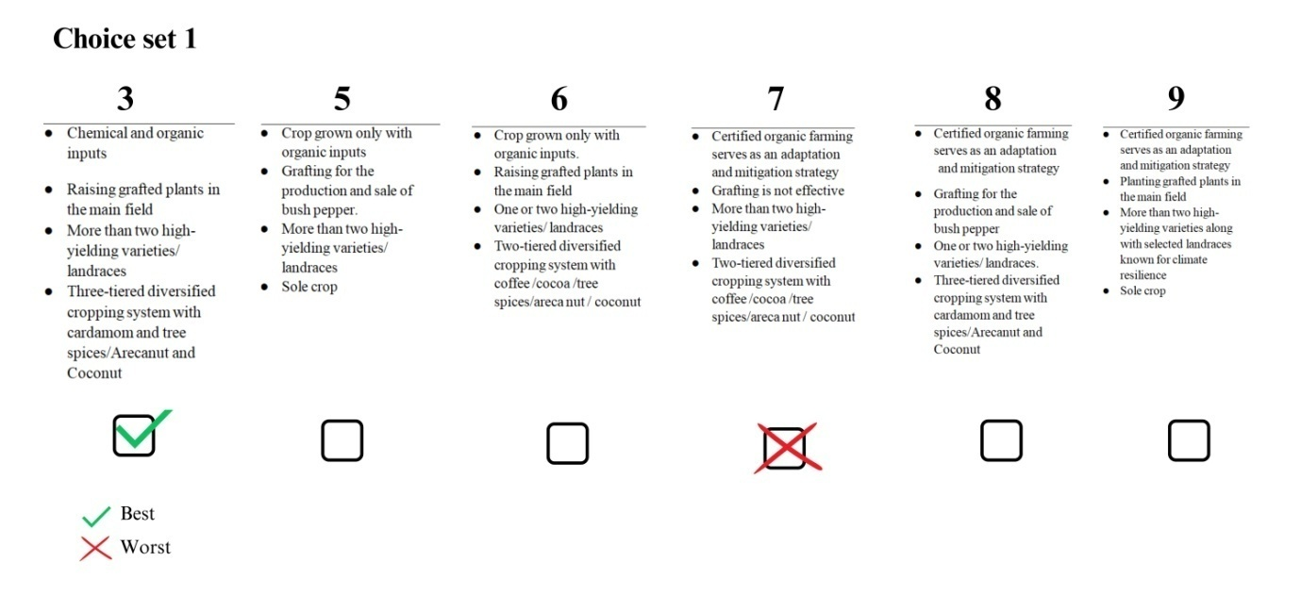

Figure 2 A model choice set consisting of profiles 3,5,6,7,8 and 9

**2.7 Statistical Analysis**

2.7.1 Counting method

Consider that there are *P* profiles and *N* respondents. The counting approach calculates Best Worst Scale scores (BWS scores) based on the number of times (*i*.*e*., the frequency or count) profile *i* is selected as the best ($B_{ij}$.) or worst ($W_{ij}$.) profile among all the questions for *j*threspondent, where *i* = 1,2,…, *P* and *j*=1,2,…, *N*. An aggregated Best Worst score of *i*thprofile (${BW}_{i}$) and mean standardizedBest Worst score ($mean{std. BW}_{i}$) is calculated for each profile using the equations (1) and (2) (Finn & Louviere 1992; Lee, Soutar &Louviere 2007a; Cohen 2009; Mueller, Francis &Lockshin 2009).The frequency with which profile *i* is selected as the bestacross all questions for *N* respondents is defined as $B_{i}$ . Similarly, the frequency with which profile *i* is selected as the worst item is defined as $W_{i}$ . Where $B_{i}=\sum_{j=1}^{N}{B_{ij}},W_{i}=\sum_{j=1}^{N}{W_{ij}}$. *r* is the frequency with which profile *i*appears across all choice sets.A square root of the ratio of $B_{i}$ and $W_{i}$ for the *it*h profile ($sqrt.{BW}_{i}$)and standardized scoreis calculated using equation (3) and (4).

$${BW}_{i}=B_{i}-W_{i}$$

**(1)**

$${meanstd. BW}_{i}=\frac{B_{i}-W_{i}}{Nr}$$

**(2)**

$$sqrt.{BW}_{i}=\sqrt{\frac{B_{i}}{W_{i}}}$$

**(3)**

$$std.sqrt.{BW}_{i}=\frac{sqrt.{BW}_{i}}{max.sqrt.{BW}_{i}}$$

**(4)**

Where $max.sqrt.{BW}_{i}$  is the maximum value of $sqrt.{BW}_{i}$ .Profiles with higher ${BW}_{i}$ scores and $sqrt.{BW}_{i}$, accompanied by lower standard deviations ${std. BW}_{i}$ and $std.sqrt.{BW}_{i}$, exhibit more consistent and widely accepted preferences among respondents. Conversely, profiles with higher standard deviations may indicate greater variability in respondents' perceptions, suggesting diverse or polarized opinions regarding the desirability of those profiles. Hence, while high scores indicate favourable profiles, evaluating their standard deviations offers insights into the consensus or variability in respondents' preferences, aiding in the interpretation of the overall preference landscape. This suggests that profiles with high scores are perceived as particularly favourable or effective in the context of the climate resilience strategies under consideration.

2.7.2 Modelling Approach

In addition to analysing responses at the profile level, it is imperative to gain clarity at the attribute level as well. This involves identifying the most preferred attribute levels to ensure a comprehensive understanding of respondents' preferences. By examining preferences at the attribute level, we can identify the specific attributes and attribute levels that are most favoured by respondents. This process enables us to consider any potential combinations of attributes that may not have been explicitly addressed in the study. Understanding the preferred attribute levels allows for the exploration of alternative combinations that align with respondents' preferences. The modelling approach employs discrete choice models to analyse the responses, with the dataset formatted according to the selected model specifications. Specifically, a maximum difference (maxdiff) model, as outlined by Lancsar*et al*. (2013) and Marley &Pihlens (2012), is utilized for the analysis. This model assumes that respondents derive utility from each profile within a choice set and select the best and worst profiles based on their subjective utilities. In the maxdiff model, respondents are assumed to select profile *i*as the best and profile *j* (where *i* ≠ *j*) as the worst because the difference in utility between these two profiles represents the greatest utility difference among all possible pairings. The number of utility differences in a pair is equal to the number of possible pairs in which profile *i* is selected as the best and profile *j* is selected as the worst from *P* profiles, calculated as *P* × (*P*-1).

The probability of selecting profiles from a choice set S for each model can be expressed using the conditional logit model. Under assumptions such as a choice set consists of nine profiles S={1,2,3,…,9} respondent *k* selected Profile *i* as the first best (FB), Profile j as the first worst (FW). Where *i* ≠ *j* = 1,2,…, *P* and *k* =1,2,…, *N*. then the probability can be expressed using the equation 5

$$\operatorname{Pr}\left(FB=,WB=\right)=\frac{exp⁡(v_{i}-v_{j})}{\sum_{i,j∈S,i≠j}{exp⁡(v_{i}-v_{j})}}$$

**(5)**

where $v_{i}=x_{i}^{'}β$ ; $x_{i}^{'}$  is a vector of attribute-level variables for profile *i*; and $β$  is a vector of the coefficients to be estimated.

**3. Result and discussion**

Best Worst scores were calculated using equations 1, 2, 3, and 4 and the results are presented in Table 5 below. The profiles were ranked accordingly based on the mean ${BW}_{i}$, mean ${std. BW}_{i}$ and $sqrt.{BW}_{i}$ values.

|  |  |  |  |  |  |  |  |  |
| --- | --- | --- | --- | --- | --- | --- | --- | --- |
| Profile | $$B_{i}$$ | $$W_{i}$$ | $${BW}_{i}$$ | Rank | Mean ${BW}_{i}$ | Mean $${std. BW}_{i}$$ | $$sqrt.{BW}_{i}$$ | $$std.sqrt.{BW}_{i}$$ |
| 1 | 52 | 415 | -363 | 9 | -2.420 | -0.303 | 0.354 | 0.104 |
| 2 | 133 | 202 | -69 | 6 | -0.460 | -0.058 | 0.811 | 0.239 |
| 3 | 167 | 258 | -91 | 7 | -0.607 | -0.076 | 0.805 | 0.237 |
| 4 | 379 | 33 | 346 | 1 | 2.307 | 0.288 | 3.389 | 1.000 |
| 5 | 133 | 192 | -59 | 5 | -0.393 | -0.049 | 0.832 | 0.246 |
| 6 | 78 | 178 | -100 | 8 | -0.667 | -0.083 | 0.662 | 0.195 |
| 7 | 255 | 169 | 86 | 4 | 0.573 | 0.072 | 1.228 | 0.362 |
| 8 | 262 | 143 | 119 | 3 | 0.793 | 0.099 | 1.354 | 0.399 |
| 9 | 333 | 202 | 131 | 2 | 0.873 | 0.109 | 1.284 | 0.379 |

Table 5 Best worst score calculated based on counting method for nine profiles

The scatter plot in Figure 3, depicting the mean BWS score (mean ${BW}_{i}$) against the standard deviation of respondents' preferences, offers insights into the variability of preferences for different climate resilience strategies represented by profiles. Profile 4 notably distinguishes itself with a substantially high mean BWS score of 2.307 and a comparatively low standard deviation. This suggests that Profile 4 embodies a climate resilience strategy that resonates strongly with respondents, eliciting consistently positive evaluations across the board. In contrast, the majority of other profiles received negative or near-zero scores, indicating greater variability and ambiguity in respondents' perceptions regarding their effectiveness in enhancing climate resilience. Therefore, Profile 4 emerges as a standout choice, signifying a robust and widely accepted climate resilience strategy among respondents, characterized by its effectiveness and consensus in addressing climate-related challenges.

In addition to Profile 4, Profiles 7, 8, and 9 also demonstrated positive BWS scores indicating their effectiveness as climate resilience techniques. These profiles are grouped closely together in the plot, following Profile 4, with BWS values of 0.573, 0.793, and 0.873, respectively. This clustering suggests that these profiles share similarities in their perceived efficacy and appeal among respondents. While Profile 4 stands out as the most favoured option with the highest BWS score, Profiles 7, 8, and 9 follow behind, representing viable and promising climate resilience techniques. Profile 9 has high standard deviation indicating a varied response among the respondents. Together, these profiles contribute to a repertoire of strategies that respondents view positively in terms of their potential to enhance resilience to climate-related challenges. Profile 1 is the least preferred. Figure 4 displays the rank order arrangement of the profiles along with their ${meanstd. BW}_{i}$ scores, effectively summarizing the aforementioned findings. From figure 5 it is clear that profile 4 has less negative BW scores and it is noteworthy that Profile 7, 8, 9 has also achieved a maximum BW score value 8 for several respondents but also gained considerable high negative values indicative of mixed responses.

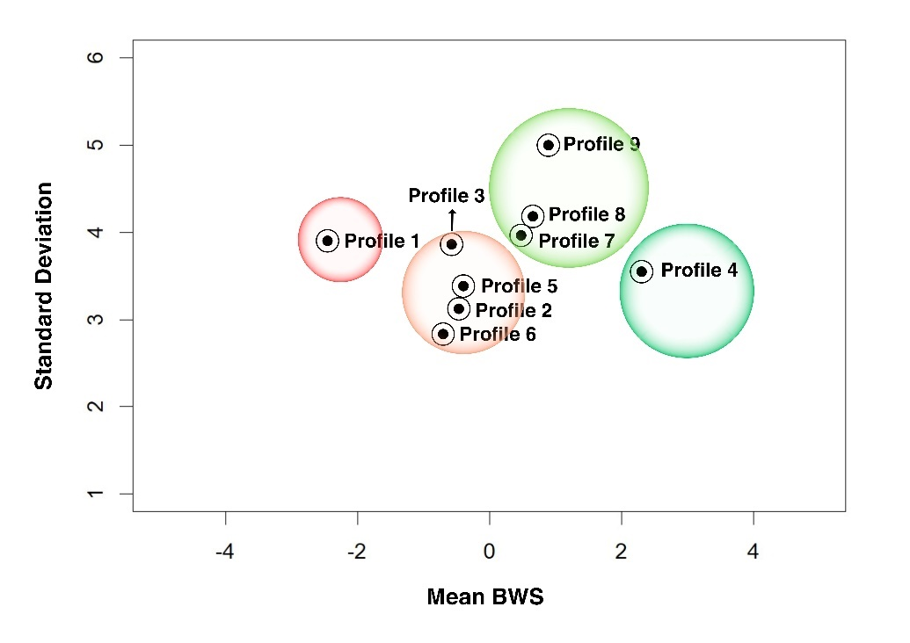

Figure 3 Scatterplot based on mean ${BW}_{i}$ and its Standard deviation

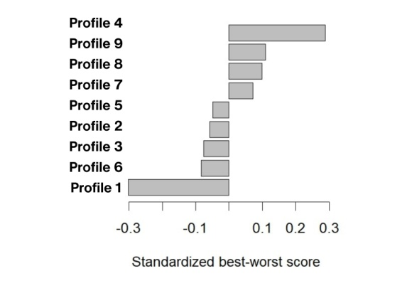

Figure 4 Rank order arrangement of profiles along with ${meanstd. BW}_{i}$

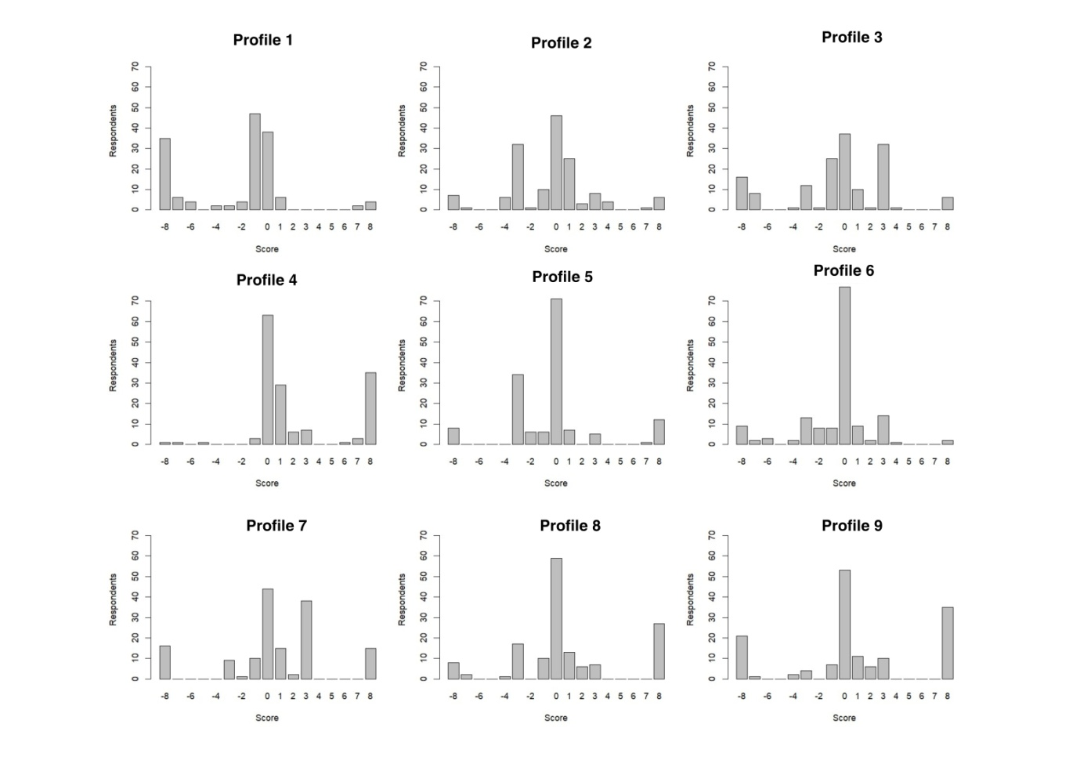

Figure 5Frequency of Individual Best Worst (BW) Scores of Respondents

A utility function is developed for the purpose of fitting a conditional logistic model to the responses on the basis of the maxdiff model to study the attribute level preference. While constructing utility function the attribute levels (Table 1), the following attribute levels were considered as references. (A1) A combination of chemical and organic methods proves more effective for adapting to climate change, (B2) Production and sale of bush pepper plants having ornamental and culinary value grafted on *Piper colubrinum* for home gardens. (C1) One or two high-yielding varieties/ landraces, (D1) Sole crop of the corresponding profile are considered as a reference for dummy variables.These attribute levels were considered as reference levels because farm products derived from a hybrid of chemical and organic management lack the market attribute specificity in asset quality and do not promote long-term climate adaptation. Farmers gave a varied response towards grafting technology in black pepper attributed to its perennial nature, prompts this study to explore the spectrum of adoption, ranging from complete rejection to full integration. The analysis of secondary data on the adoption of black pepper varieties in Kerala revealed the predominance of *Karimunda*and *Panniyur*1 varities across all pepper-growing districts. However, considering the importance of genetic diversity beyond these two varieties, further exploration was deemed necessary. Hence, C1 was chosen as the reference level. Given that sole cropping is the least favoured cropping system for climate-resilient farming, this study aims to explore variations beyond this level in the choice analysis.

By designating specific attribute levels (A1, B2, C1, D1) as reference points, the utility function contrasts the preference for other attribute levels against these references. This comparison enables the identification of how respondents' preferences deviate from or align with the chosen reference levels.

Accordingly, the systematic component of a utility function for the nine profiles (*i* = 1,2,…, 9) is as follows

$$v_{i}=β_{1}A_{2}+β_{2}A_{3}+β_{3}B_{1}+β_{4}B_{3}+β_{5}C_{2}+β_{6}C_{3}+β_{7}D_{2}+β_{8}D_{3}$$

Where $A_{2}$, $A_{3}$, $B_{1}$, $B_{3}$, $C_{2}$, $C_{3}$, $D_{2}$, $D_{3}$ are dummy variable taking the value of 1 if *i*th profile has the attribute level A2, A3, B1, B3, C2, C3, D2, D3 respectively , 0 otherwise;. $β$ s are coefficients (parameters) for these variables. Conditional logistic model is fitted using *clogit()* function of*survival* package (Therneau,2023) in R (R Core Team, 2021).

|  |  |  |  |  |
| --- | --- | --- | --- | --- |
| Attribute level | $$β$$ | Odds ratio | se($β$) | Pr(>|z|) |
|  | 0.793 | 2.210 | 0.078 | 0.000** |
| $$A_{3}$$ | 0.148 | 1.160 | 0.082 | 0.069ns |
|  | -0.654 | 0.520 | 0.079 | 0.000** |
| $$B_{3}$$ | -0.407 | 0.666 | 0.08 | 0.000** |
| $$C_{2}$$ | 1.051 | 2.86 | 0.085 | 0.000** |
| $$C_{3}$$ | 0.422 | 1.524 | 0.081 | 0.000** |
| $$D_{2}$$ | 0.414 | 1.513 | 0.081 | 0.000** |
| $$D_{3}$$ | 0.077 | 1.080 | 0.078 | 0.329ns |

Table 6 Conditional Logistic Regression Results for Attribute Level Preferences

The results of the conditional logistic regression analysis presented in Table 6 provide insightful implications regarding the influence of different attribute levels on respondents' preferences for climate resilience strategies. The highly significant coefficient ($β_{1}$) of 0.793 associated with attribute level A2, representing the exclusive use of organic inputs in crop cultivation, indicates a substantial positive impact on preference. This suggests that respondents are 2.210 times more likely to favour attribute level A2 compared to the reference level, emphasizing the perceived effectiveness of organic farming practices in adapting to and mitigating climate change-related challenges. Despite increase in weighted average maintenance cost (Table 7) as estimated during the study (127% higher than conventional methods), farmers prefer organic farming as they consider it as a long term decision for climate adaptation. Farmers view organic farming as a significant long-term investment due to its promotion of autonomy, economic efficiency, and resilience factors in farm management.

|  |  |  |  |  |
| --- | --- | --- | --- | --- |
| Particulars | Yield increasing phase | Yield stabilising phase | Yield declining phase | Mean (weighted) |
| Conventional | 73034 | 81340 | 60679 | 70311 |
| Organic | 90099 | 91801 | 75811 | 89818 |

Table 7: Average maintenance cost in conventional and organic method of cultivation (INR/acre)

In contrast, attribute levels B1 and B3 demonstrate significant negative effects ( $β_{3}=-0.654, β_{4}=-0.407)$ on preference with odds ratio less than one when compared to reference level, indicating that respondents are less inclined to favour these levels compared to the reference level, which involves the production and sale of bush pepper plants grafted on *Piper colubrinum* for home gardens. Farmers prefer this reference level due to the proven effectiveness of the grafting technique in propagating bush pepper in home garden settings, where irrigation costs are manageable. The black pepper crop in Kerala confronts various challenges, including diseases, pests, and climate variability. Foot rot disease, particularly prevalent during the southwest monsoon season, leads to significant crop losses (Anju *et al*., 2023). In response, farmers seeking to enhance resistance to this disease and impart better flood tolerance have turned to grafted plants on the rootstock *Piper colubrinum* in the main field. Farmers have noted that grafted plants display robust growth, establish quickly, and demonstrate resilience to flood and foot rot in field conditions. This decision-making process is shaped by tacit knowledge, aiding farmers in navigating unfamiliar situations within the constraints of bounded rationality. Moreover, farmers proficient in grafting are exploring the option of grafting on *Piper colubrinum* for bush pepper production as a means to enhance their income. The diverse skill sets possessed by members of the farmer family are organised into routines and drive decision-making behaviour.(Meisch *et al*., 2022)

However, attribute level B3, which pertains to raising grafted plants with irrigation in the main field, experiences a downward trend in preference. This trend may be attributed to limited scientific validation and evidence regarding the efficacy of grafted plants in field conditions. Some studies suggest that grafted plants have limitations, such as a relatively short lifespan of nine to ten years and a lower yield of fruit-bearing spikes. Additionally, the requirement for regular irrigation poses challenges, particularly for smallholder farmers with limited access to resources (Hema *et al*., 2007). Therefore, the lack of scientific validation (Gilles et al., 2023)and the practical challenges associated with irrigation may contribute to the reduced preference for this adaptation practice among the majority of farmers.

Additionally, attribute level C2 stands out with a highly significant odds ratio of 2.86, indicating a strong preference among respondents. Most farmers prefer C2, raising multiple varieties or landraces, with popular choices being *Panniyur* 1, *Panniyur* 5, *Vijay*, and the landrace *Karimunda*, alongside others. State and private farms propagate these types for their bold, superior-quality berries, favoured by traders based on litre weight. C3 also is preferred which included selected landraces known for climate resilience, showing its positive impact on preference at the attribute level. Farmers promote climate-resilient landraces and generate income by selling rooted seedlings of these landraces. This underlines the importance of landrace diversity in farmers’ CCRDs.(Wertz-Kanounnikoff *et al*., 2011). Peermade Development Society (PDS), a farm-centric Non-Governmental Organization, significantly contributes to raising stakeholders' awareness regarding climate-resilient landraces.(Adhikari & Taylor, 2012)

Furthermore, attribute levels D2 and D3 representing two and three tiered cropping system demonstrate significant coefficients with odds ratios greater than 1, indicating a heightened preference compared to the reference level which is sole crop. This preference is likely influenced by the traditional agro-forestry landscapes where black pepper cultivation in India occurs. These landscapes often feature intercropping with coffee, arecanut, coconut, and tree spices like clove, nutmeg, allspice, and cinnamon. In regions such as Idukki and parts of Wayanad district, traditional black pepper cultivation has shifted towards three-tier diversified systems centered on cardamom cultivation. Farmers frequently replace vines that are declining due to foot rot disease, senility, or other causes. The newly planted vines face challenges in flourishing, especially amidst cardamom intercropping. A gradual shift in the cropping system is underway.(Fazey *et al*., 2016)

Farmers frequently replace vines that are declining due to foot rot disease, senility, or other causes. The newly planted vines face challenges in flourishing, especially amidst cardamom intercropping. A gradual shift in the cropping system is underway.

The intensified shading from cardamom ground cover impedes black pepper vine growth, necessitating a gradual shift. This transition has gained momentum recently due to rising cardamom prices, which agrees with the study of Biggs *et al*. (2013) Coffee provides natural shade and mulching, particularly beneficial in inter-row spaces, mitigating soil parching observed after floods in 2018 and 2019(Kandiannan*et al*., 2014). Discussions with experts on best agronomic practices for black pepper and previous studies like that of Chengappa*et al*. (2017), emphasize the importance of integrating coffee, cocoa, and tree spices into black pepper-diversified systems to ensure sustainable production. Despite this, the preference for three-tier diversified systems with cardamom suggests a strategic, long-term adaptation to buffer against price volatility in black pepper and cardamom markets. The study thus points to the tipping points in decision-making that may lead to transformative changes in the hills (Sgroi & Sciancalepore, 2022).

In lowlands where cardamom and coffee are absent, diversified systems comprising black pepper, arecanut and coconut are prevalent. Additionally, tree spices and cocoa are cultivated within such systems, further enhancing resilience and economic viability.

**4. Conclusion**

Through a comprehensive analysis of Best-Worst Scaling (BWS) scores, conditional logistic regression, and attribute level preferences, several key observations have emerged on complex dynamics underlying decision-making processes related to climate change resilience strategies among smallholder black pepper farmers in Kerala, India. Profile 4, characterized by its exclusive use of organic inputs in crop cultivation, no affinity for grafted plants in the main field,three-tiered diversified cropping systems with cardamom as the lowest tier, inclination towards preserving selected landraces known for climate resilience, emerged as the most favoured climate resilience strategy among respondents. This profile gives them sustainable benefits in the long run. The attribute level analysis also indicates that farmers perceive organic farming as conducive to promoting autonomy, long-term economic efficiency, resilience in farm management, and overall sustainability of their farms, even in light of the accompanying increase in maintenance costs. Notably, farmers exhibit reluctance towards raising plantations with grafted black pepper plants on *Piper colubrinum* due to concerns regarding irrigation requirements and skepticism towards the technology. Conversely at the attribute level, corresponding to the choice of grafting with the rootstock *Piper colubrinum,* the production and sale of bush pepper grafts with ornamental and culinary value for home gardens showed preference. This preference is derived from the fewer risks in including the practice in homestead cultivation compared to the main field, farmer routines rooted in their skills in grafting and nursery management, and alternative income boost obtained through the sale of grafts.

Attributes related to landrace diversity and diversified cropping systems demonstrated significant positive effects on preference, indicating respondents' inclination towards preserving genetic diversity and integrating multiple crops into their farming systems. Farmers' awareness of nature-based assets is gradually increasing, albeit at a slow pace, exerting influence on this trend. Most farmers prefer the attribute level, “raising more than two varieties or landraces, however, when farmers selected preferred profiles, they prioritized profile 4, which included a preference forselected landraces known for climate resilience. Also, black pepper as a sole crop is the least preferred choice among smallholder farmers.The implication of this decision on the ‘attributes of markets’ofblack pepper can be further explored (Sgroi & Sciancalepore, 2022)

The preference revealed in the choice experiment for three-tier diversified systems incorporating cardamom implies a strategic, long-term adaptation to mitigate the effects of price volatility in black pepper and cardamom markets. This preference reflects a strategic, long-term adaptation approach aimed at mitigating the effects of price volatility in agricultural markets and enhancing overall farm resilience. However, a pertinent concern to be addressed is whether this trend will ultimately lead to a reduction in the acreage of standing black pepper in the study area.The analysis of adaptive pathways will shed light on the future implications of this transition.(Newsham *et al*., 2023)

In conclusion, while our current study didn't incorporate gender-disaggregated choice analysis for climate adaptation at the farm and family level, it's an essential avenue for future research. Overall, the choices are aligned with the global demand for black pepper in terms of its asset specificity and sustainability concerns of the market.

**Acknowledgments**

The authors are grateful to Kerala Agricultural University for the support and funding received for the conduct of survey.

**Disclosure Statement**

There is no any potential conflict of any interest to report

**References**

Adhikari, B., & Taylor, K. (2012). Vulnerability and adaptation to climate change: A review of local actions and national policy response. *Climate and Development*, 4(1), 54–65. <https://doi.org/10.1080/17565529.2012.664958>

Ahoudou, I., Sogbohossou, D. E. O., FassinouHotegni, N. V., et al. (2023). Farmers’ selection criteria for sweet potato varieties in Benin: An application of Best-Worst Scaling. *Experimental Agriculture*, 59, e25. <https://doi.org/10.1017/S0014479723000224>

Anith, K. N., Aswini, S., Varkey, S., Radhakrishnan, N. V., & Nair, D. S. (2018). Root colonization by the endophytic fungus Piriformospora indica improves growth, yield and piperine content in black pepper ( Piper nigurm L.). *Biocatalysis and Agricultural Biotechnology*(Vol. 14, pp. 215–220). Elsevier BV. <https://doi.org/10.1016/j.bcab.2018.03.012>

Anju AB, Natarajan C, Preetha R, Rajan SA, Soumya VI, Anith KN. (2023). Bacterization with Endospore-forming Bacillus spp. Promotes Plant Growth and Suppresses Foot Rot Disease in Black Pepper (Piper nigrum L.) in the Nursery. *Journal of Pure and Applied Microbiology*, 17(2), 768-779. <https://doi.org/10.22207/JPAM.17.2.02>

Becker, M. C. (2004). Organizational routines: a review of the literature. *Industrial and Corporate Change* (Vol. 13, Issue 4, pp. 643–678). Oxford University Press (OUP). <https://doi.org/10.1093/icc/dth026>

Biggs, E. M., Tompkins, E. L., Allen, J., Moon, C., & Allen, R. (2013). Agricultural adaptation to climate change: observations from the Mid-Hills of Nepal. *Climate and Development*, 5(2),165–173. <https://doi.org/10.1080/17565529.2013.789791>

Burnham, M., & Ma, Z. (2016). Climate change adaptation: factors influencing Chinese smallholder farmers’ perceived self-efficacy and adaptation intent. Regional Environmental Change, 17(1), 171–186. <https://doi.org/10.1007/s10113-016-0975-6>

Chengappa, P. G., Devika, C. M., &Rudragouda, C. S. (2017). Climate variability and mitigation: perceptions and strategies adopted by traditional coffee growers in India. *Climate and Development*, 9(7), 593–604. <https://doi.org/10.1080/17565529.2017.1318740>

Chethna A, Nagaraja N, Chengappa P, Gracy C. (2010). Geographical Indications for kodagu coffee a socio-economic feasibility analysis. *Agricultural Economics Research Review*, 23(3), 97-103.

Cohen, E. (2009). Applying Best-Worst Scaling to Wine Marketing. *International Journal of Wine Business Research*, 21(1), 8–23. <https://doi.org/10.1108/17511060910948008>

Delfiyan, F., Yazdanpanah, M., Forouzani, M., & Yaghoubi, J. (2020). Farmers’ adaptation to drought risk through farm–level decisions: the case of farmers in Dehloran county, Southwest of Iran. *Climate and Development*, 13(2), 152–163. <https://doi.org/10.1080/17565529.2020.1737797>

Fazey, I., Wise, R. M., Lyon, C., Câmpeanu, C., Moug, P., & Davies, T. E. (2016). Past and future adaptation pathways. Climate and Development, 8(1), 26–44. <https://doi.org/10.1080/17565529.2014.989192>

Finn, A., & Louviere, J. J. (1992). Determining the Appropriate Response to Evidence of Public Concern: The Case of Food Safety. *Journal of Public Policy & Marketing*, 12–25. <https://doi.org/10.1177/074391569201100202>

Fiori, S. (2011). Forms of Bounded Rationality: The Reception and Redefinition of Herbert A. Simon’s Perspective. *Review of Political Economy*, 23(4), 587–612. <https://doi.org/10.1080/09538259.2011.611624>

Gigerenzer, G., & Todd, P. M. (1999). *Simple heuristics that make us smart*. Oxford University Press, USA.

Gilles, J. L., García, M., Yucra, E. S., Quispe, R., Poma, A., Quispe, J. M., Rojas, K., & Cabrera, P. (2023). Validating local meteorological forecast knowledge in the Bolivian Altiplano: moving toward the co-production of agricultural forecasts. Climate and Development, 15(4), 280–291. <https://doi.org/10.1080/17565529.2022.2077692>

Government of Kerala [GOK]. (2018). *Soil health status in Kerala in post flood scenario*. Department of Soil Survey and Soil Conservation, Trivandrum. Retrieved from <https://sdma.kerala.gov.in/wp-content/uploads/2020/08/Soil-Flood.pdf>

Grömping, U. (2018). R Package DoE.base for Factorial Experiments. *Journal of Statistical Software*, 85(5), 1–41. <https://doi.org/10.18637/jss.v085.i05>

Grothmann, T., & Patt, A. (2005). Adaptive capacity and human cognition: The process of individual adaptation to climate change. Global Environmental Change, 15, 199–213. https://doi.org/10.1016/j.gloenvcha.2005.01.002

Habtemariam, L. T., Gandorfer, M., Kassa, G. A., & Sieber, S. (2019). Risk experience and smallholder farmers’ climate change adaptation decision. Climate and Development, 12(4), 385–393. <https://doi.org/10.1080/17565529.2019.1630351>

Hema M, Kumar R, Singh NP. (2007). Volatile price and declining profitability of black pepper in India: disquieting future. *Agricultural Economics Research Review*, 20, 61–76. <https://doi.org/10.22004/ag.econ.47425>

Kandiannan, K., Krishnamurthy, K.,& Gowda, S. & Muthuswamy, Anandaraj. (2014). Climate Change and Black Pepper Production. Indian Journal of Arecanut, Spices and Medicinal Plants. 16. 31-37

Lancsar, E., Louviere, J., Donaldson, C., Currie, G., & Burgess, L. (2013). Best Worst Discrete Choice Experiments in Health: Methods and an Application. *Social Science & Medicine*, 79, 74–82. <https://doi.org/10.1016/j.socscimed.2012.10.007>

Lee, J. A., Soutar, G. N., & Louviere, J. (2007). Measuring Values Using Best-Worst Scaling: The Lov Example. *Psychology & Marketing*, 24(12), 1043–1058. <https://doi.org/10.1002/mar.20197>

Louviere, J. J., Flynn, T. N., & Marley, A. A. J. (2015). *Best–Worst Scaling: Theory, Methods and Applications*. Cambridge, UK: Cambridge University Press.

March, J. G. (1978). Bounded rationality, ambiguity, and the engineering of choice. *The Bell Journal of Economics*, 9(2), 587-608.

Marley, A. A. J., &Pihlens, D. (2012). Models of Best-Worst Choice and Ranking Among Multiattribute Options (Profiles). *Journal of Mathematical Psychology*, 56, 24–34. <https://doi.org/10.1016/j.jmp.2011.09.001>

Meisch, S. P., Bremer, S., Young, M. T., &Funtowicz, S. O. (2022). Extended Peer Communities: Appraising the contributions of tacit knowledges in climate change decision-making. Futures, 135, 102868. <https://doi.org/10.1016/j.futures.2021.102868>

Mueller, S., Francis, I. L., &Lockshin, L. (2009). Comparison of Best–Worst and Hedonic Scaling for the Measurement of Consumer Wine Preferences. *Australian Journal of Grape and Wine Research*, 15(3), 205–215. <https://doi.org/10.1111/j.1755-0238.2009.00049.x>

Nelson, R. R., & Winter, S. G. (1982). *An Evolutionary Theory of Economic Change*. Belknap press of Harvard University Press.

Newsham, A., Naess, L. O., Mutabazi, K., Shonhe, T., Boniface, G., &Bvute, T. (2023). Precarious prospects? Exploring climate resilience of agricultural commercialization pathways in Tanzania and Zimbabwe. *Climate and Development*, 0(0), 1–15. <https://doi.org/10.1080/17565529.2023.2229775>

Ola, O., & Menapace, L. (2020). Smallholders’ perceptions and preferences for market attributes promoting sustained participation in modern agricultural value chains. Food Policy, 97, 101962. <https://doi.org/10.1016/j.foodpol.2020.101962>

Phiri, C. K., Alimoso, N., Mabedi, F., &Chitedze, G. (2024). An overview of spice production, promotion, and economic benefits in Malawi. *Journal of Crop Improvement,* 22(1), 1542-7528. <https://doi.org/10.1080/15427528.2024.2336265>

R Core Team. (2021). *R: A language and environment for statistical computing*. R Foundation for Statistical Computing, Vienna, Austria. https://www.R-project.org/

Ravindran, P. N., &Kallupurackal, J. A. (2012). Black pepper. *Handbook of Herbs and Spices*, 86–115. <https://doi.org/10.1533/9780857095671.86>

Rogers, R. W. (1983). Cognitive and physiological processes in fear appeals and attitude change: A revised theory of protection motivation. In Social Psychology: A sourcebook, edited by Cacioppo, J. R., Petty, R. E., pp. 153-176, Guilford, 1983.

Schneider, R. C., Zaval, L., & Markowitz, E. M. (2021). Positive emotions and climate change. *Current Opinion in Behavioral Sciences*, 42, 114-120. <https://doi.org/10.1016/j.cobeha.2021.04.009>

Sailer, M. O. (2022). *crossdes: Construction of Crossover Designs*. R package version 1.1-2. <https://CRAN.R-project.org/package=crossdes>

Sgroi, F., & Sciancalepore, V. D. (2022). Dynamics of structural change in agriculture, transaction cost theory and market efficiency: The case of cultivation contracts between agricultural enterprises and the food industry. Journal of Agriculture and Food Research, 10, 100396. <https://doi.org/10.1016/j.jafr.2022.100396>

Shittu, A. M., Kehinde, M. O., Adeyonu, A. G., & Ojo, O. T. (2021). Willingness to accept incentives for a shift to climate-smart agriculture among smallholder farmers in Nigeria. *Journal of Agricultural and Applied Economics*, 53(4), 531-551. <https://doi.org/10.1017/aae.2021.19>

Simon, H. A. (1955). A Behavioral Model of Rational Choice. *Quarterly Journal of Economics*, 69(1), 99–118. <https://doi.org/10.2307/1884852>

Smith, B., Burton, I., Klein, R., et al. (1999). The Science of Adaptation: A Framework for Assessment. *Mitigation and Adaptation Strategies for Global Change*, 4, 199–213.<https://doi.org/10.1023/A:1009652531101>

Therneau, T. (2023). A Package for Survival Analysis in R. R package version 3.5-7. <https://CRAN.R-project.org/package=survival>

Tversky, A., & Kahneman, D. (1974). Judgment Under Uncertainty: Heuristics and Biases. *Science*, 185(4157), 1124–1131. <https://doi.org/10.1126/science.185.4157.1124>

Varghese, R., & Ray, J. G. (2024). Sustainability of black pepper production: A critical analysis of physicochemical soil parameters concerning variables in pepper fields of South India. *Ecological Frontiers*.<https://doi.org/10.1016/j.ecofro.2024.01.005>

Wertz-Kanounnikoff, S., Locatelli, B., Wunder, S., & Brockhaus, M. (2011). Ecosystem-based adaptation to climate change: What scope for payments for environmental services? Climate and Development, 3(2), 143–158. <https://doi.org/10.1080/17565529.2011.582277>